Who Gets Identified? Analyzing Equity in Learning Disability Diagnosis Across Race, Gender, and Access Barriers

POLICY ISSUE

Education equity remains a central challenge in U.S. child and youth policy. Learning disabilities are conditions that affect how children acquire and use academic skills such as reading, writing, and mathematics. Based on the 2019 population, one in five students have learning and attention issues. This number represents 66.5 million individuals and 11.2 million students in elementary and secondary schools having learning disabilities. Research on sociodemographic indicators and their correlation with learning disabilities confirms a predictive relationship between the two and highlight how unequal access to early screening can translate into long-term differences in educational attainment.

Findings from various studies indicate that factors such as health insurance status, nutrition status at home, poverty status, race, and gender are significantly associated with learning disability at home. This signals potential inequities in how educational and healthcare systems allocate resources. Addressing these barriers is essential for meeting federal mandates under Individuals with Disabilities Education Act (IDEA). Children from lower socio-economic status (SES) households are twice as likely as those from high SES households to display learning and behavior related problems. Exposure to adversity, perceptions of family economic stress, and personal financial constraints all play a role in affecting students and their learning outcomes.

RESEARCH DESIGN AND HYPOTHESES
Based on the policy issue identified, this study investigates how demographic, and household factors influence the likelihood of children being identified with a learning disability in the United States. The central research questions guiding this analysis are:
- Are there racial and gender disparities in learning disability identification among children in the United States?
- Do socio-economic and household factors such as health insurance, poverty status, home language, and metropolitan status explain these disparities?

Based on prior literature, the study tests the following hypotheses:
H1: Race is significantly associated with learning disability identification, with Black children more likely to be identified than white children
H2: Male children are more likely than females to be identified with a learning disability
H3: Household language, insurance coverage, and metro status can influence the probability of identification
H4: There are significant interactions between race and sex, which can suggest compounding effects of gender and race
These hypotheses are testable utilizing multivariate logistic regression enabling the analysis to estimate the magnitude and statistical significance of each factor’s contribution to learning disability identification. The variable of interest is whether the child has a learning disability or not.

Analytical Strategy: The analysis for this paper is divided in three stages:
- Descriptive Statistics: Summarize the prevalence of learning disabilities across different demographic subgroups.
- Bivariate Analysis: Test associations between the dependent variable and independent variables of race and gender using chi-square tests.
- Multivariate Logistic Regression: Estimate the log odds of a child having a learning disability as a function of race, sex, and control variables.

The model specification is as follows:
logit(P(learn_dis=1)) =β0​+β1​(race)+β2​(sex)+β3​(metro)+β4​(hh_language) +β5​(curr_ins) +ϵ

All analyses were conducted using R using the glm () function with binomial family, and data cleaning and variable recoding were performed using the dplyr and janitor packages. Results are interpreted in terms of odds ratios, highlighting both statistical significance and policy relevance.

DATA SELECTION AND JUSTIFICATION

The data used for this analysis comes from the National Survey of Children’s Health (NSCH), a nationally representative survey conducted by the U.S. Census Bureau in collaboration with the Maternal and Child Health Bureau. The NSCH provides comprehensive data on the physical and emotion health of children as well as factors that relate to the well-being including medical home, family interactions, and school experiences of U.S. children aged 0-17.

The NSCH provides an ideal dataset for this analysis because it captures both child-level development outcomes and household-level social determinants. Since it’s a nationally representative sampling, the findings can inform both federal and state education policy. The combination of health, education, and demographic data allows us to apply a robust multivariate research design to assess how multiple variables intersect to shape identification outcomes.
Link to the dataset: https://www.census.gov/programs-surveys/nsch/data/datasets.html

Variables of Interest:
The dependent variable is
- Learning Disability (learn_dis): A binary indicator coded as 1 if a parent reported learning disability for the children, and 0 otherwise

Independent Variable:
- Race (sc_race_r): Categorical variable (White, Black or African American, American Indian/Alaska Native, Asian, Native Hawaiian/Pacific Islander, Two or More Races)
- Sex (sc_sex): Male or Female
- Metro Status (metro_yn): Whether the household resides in a metropolitan or non-metropolitan area
- Current Insurance Status (curr_ins): Insured or Not Insured
- Poverty (poverty_group): The extent to which differing poverty levels affects learning disability identification.
- Language spoken (hh_language): English, Spanish, Other
- Access related factors:
Whether the child received care for their condition (care_unmet)

Limitations: The limitations include parent-reported diagnoses rather than administrative records which can introduce reporting bias. Additionally, the dataset does not distinguish between specific learning disability types and some variables contain nonresponse codes that reduce the sample size after cleaning. As this study relies on cross-sectional survey data, the results identify associations rather than causal relationships between demographic factors and learning disability identification. In addition, patterns of over-identification among marginalized groups may act as a confounder which reflects systemic bias in diagnostic practices rather than true prevalence of learning disabilities.

METHODS IN COURSE CONTEXT

The analytical methods outlined in the research design aligns with the course’s focus on building from simple associations to more robust inferential explanation. Logistic regression is particularly appropriate for this study as the dependent variable, learning disability is binary, and the goal is to model how changes in predictor variables alter the log-odds of identification. The inclusion of an interaction term (race x sex) situates the study within a policy framework, which is consistent with the course emphasis on testing for conditional relationships between one or more variables. Overall, the methods used which are chi-square testing and logistic regression are both statistically appropriate and policy relevant.

Sample and Preparation: All data cleaning and transformation steps were conducted in R using packages such as dplyr and janitor. The variables were recoded into consistent categorical forms and missing responses were treated as NA and excluded.
- K2q30a recoded as learn_dis
- k4q28x04 recoded as care_unmet
- metro_yn recoded as metro
- sc_sex recoded as sex
- fpl_i1 recoded as poverty_group
- sc_race_r recoded as race

ANALYSIS AND RESULTS

Table 1 presents the descriptive statistics showing the proportion of uninsured children and the proportion of children reported to have a learning disability, disaggregated by race, metropolitan status, and sex.

According to the table below, Black and American Indian/Alaska Native children show higher proportions of reported learning disabilities (10-17%) than White or Asian children (5-8% approximately). Black and American Indian children also have the highest uninsured rates across groups – often double those of their White peers. Additionally, across all racial groups, male children are more likely than females to be reported with a learning disability. This varies across racial groups; the male disability rate (7%) is lower than females (12%) in MSA areas. This pattern supports the exploration of the race x sex interaction, as the male-female gap is not uniform across racial groups. In terms of geographic context, children living in non-MSA areas have slightly higher proportions of being uninsured and having a reported disability. These findings are consistent with existing literature and research that children from minority backgrounds and those in non-urban areas face more barriers to health insurance coverage and healthcare access.

TABLE 1:

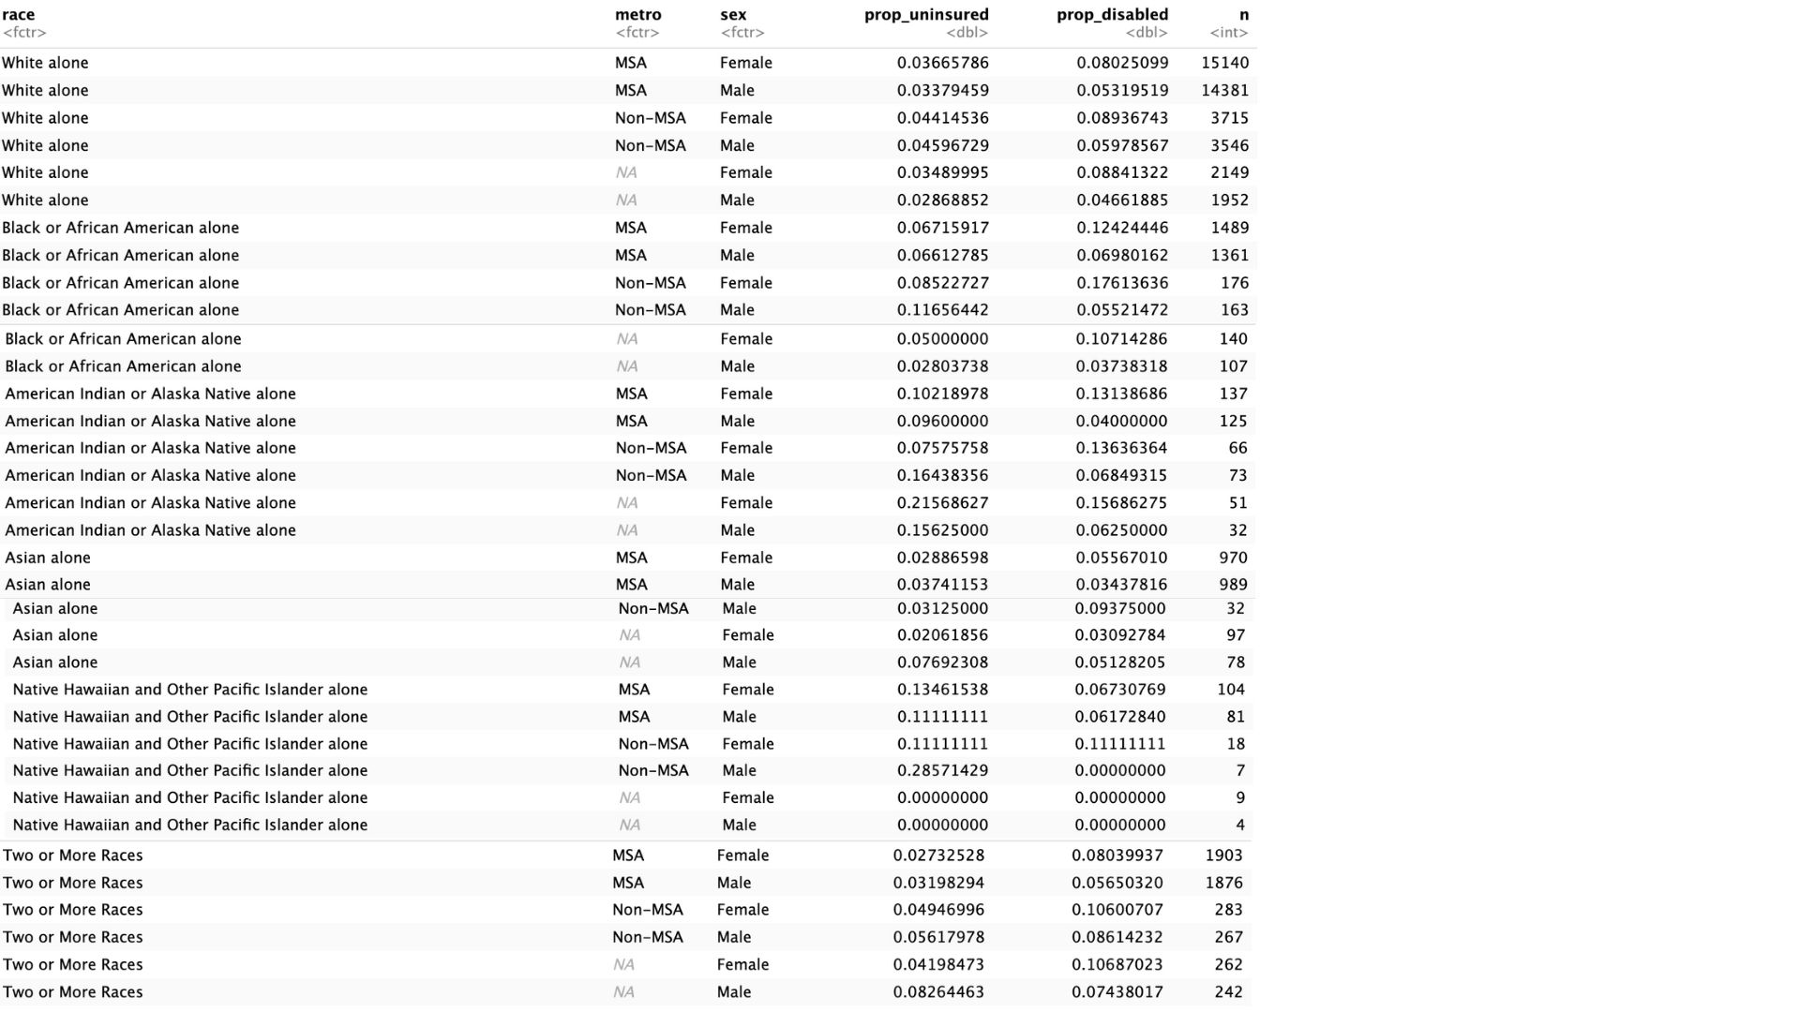

Significance Tests: To assess whether learning disability identification differs significantly across demographic groups, chi-square tests were conducted for race and sex.
Results: Table Race
X squared = 98.68, df = 5, p value < 2.2e-16. This is a statistically significant result and indicates that the proportion of children reported with a learning disability varies significantly across racial groups. Approximately, 9.4% of Black or African American children and 9.0-13% of American Indian/Alaska Native children were identified with learning disabilities. This is in comparison to roughly 6-8% of white children, and 3-6% of Asian children.
Results: Table_Sex
X squared = 192.27, df = 1, p value < 2.2e-16. This test also yielded a statistically significant result which confirms that male and female children differ significantly in the likelihood of being identified with a learning disability. The proportions show that 8.4% of females and 5.3% of males were identified.
Figure 1 illustrates the proportion of children identified with learning disability across racial groups, separated by sex. American Indian/ Alaska Native and Black children exhibit the highest prevalence rates of reported learning disabilities. Across all racial groups, female children show higher identification rates than males and this finding diverges from national trends that suggest that males have higher reported learning disabilities.
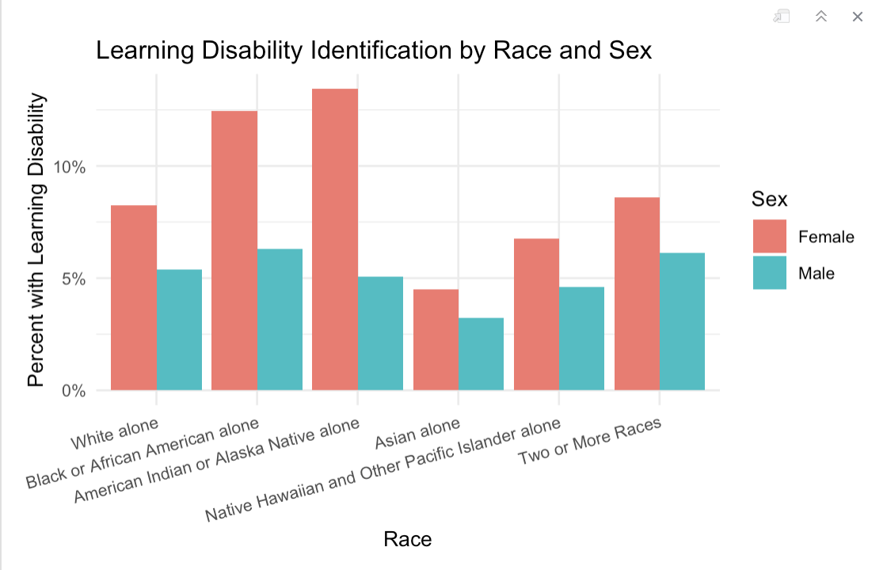

These bivariate results establish that both race and gender are significantly related to learning disability identification. While these findings do not imply causation, they underscore the need to examine intersectional and structural factors that contribute to differential identification rates.
The next stage of the analysis therefore incorporates multivariate logistic regression to control for variables (language, insurance, metro status) and to test whether these disparities persist after accounting for access-related factors.

Logistic Regression Models: The first logistic regression models look at the following regression:
glm (formula = learn_dis ~ race + metro + hhlanguage + curr_ins +
sex + poverty_group + care_unmet
family = "binomial", data = nsch_small)

TABLE 2:

Variable | Odds Ratio (95% CI) | P value
Current Insurance (Not Insured vs Insured) | 2.38 | <0.004
Sex (Male vs female) | 1.40 | 0.007
Poverty group (400% FPL) | 2.21 | <0.001
Care Unmet (no vs yes) | 2.28 | <0.001
Race_Asian | 0.053 | 0.045

Table 2 outlines the significant predictors from this model: Race_Asian, sex, current insurance, poverty group, and care unmet. The model indicated that male children had 1.40 times higher odds of having a reported learning disability compared to female children (p < .01). Uninsured children have 2.38 times higher odds of learning disability identification (p <0.01). Children with no unmet healthcare needs have 2.28 times higher odds of identification (p < 0.001). This likely indicates that consistent healthcare access facilitates early detection and diagnosis of learning disabilities. Poverty group effects show a gradient: as family income increases, the odds of identification rise. Children from households earning 400%+ of the federal poverty level are over twice as likely (OR = 2.21) to be identified as those below poverty (p < 0.001). This supports the interpretation that families with greater resources are more likely to access and advocate for evaluations.
While the bivariate chi-square test suggested higher identification among female students, this relationship reverses in the multivariate model once demographic and access factors are controlled for. This indicates that the initial gender difference was confounded by correlated variables such as race, insurance coverage, and language. After adjusting for these, male children are 1.58 times more likely than females to be identified with a learning disability — consistent with national patterns in special education identification.

Logistic Regression Model 2: To add robustness in the model, an interaction between race and sex was added to test whether gender disparities in learning disability identification vary across racial group.
The model specification is as follows:
m1 <- glm (learn_dis ~ race * sex + poverty_group + care_unmet + curr_ins,
data = nsch_small, family = "binomial")
TABLE 3:
Variable | Odds Ratio | Confidence Intervention (95%) Lower and Upper
Sex_Male | 1.58 | 1.21 – 2.08
Race: Black | 1.49 | 0.84 – 2.76
Race: Asian | 0.69 | 0.34 – 1.47
Poverty: 200 – 399% FPL | 1.42 | 1.00 -2.01
Poverty: 400% + FPL | 2.16 | 1.50 – 3.11
Care Unmet: No | 2.15 | 1.70 – 2.73
Insurance | 2.32 | 1.39 – 4.15
Asian_Male | 1.27 | - – 4.04

Table 3 outlines the interaction effect between race and sex and highlights the significant predictors outlining this model. Across most groups, males are significantly more likely than females to be identified with a learning disability, consistent with national trends. Asian children show lower odds of identification, while Black, American Indian, and NH/PI children have higher but not statistically significant odds. Children from higher-income families (400% + FPL) are more than twice as likely to be identified compared to those below the poverty line. Children with no unmet healthcare needs and those with insurance coverage also have much higher odds of being identified, underscoring how access to healthcare directly influences diagnostic opportunities. The interaction terms indicate that the magnitude of the male–female gap differs by race, but none reach strong statistical significance except for patterns consistent with smaller gender gaps among Black and multiracial children, suggesting both boys and girls are identified at relatively high rates and there is persistent male advantage across most other groups.
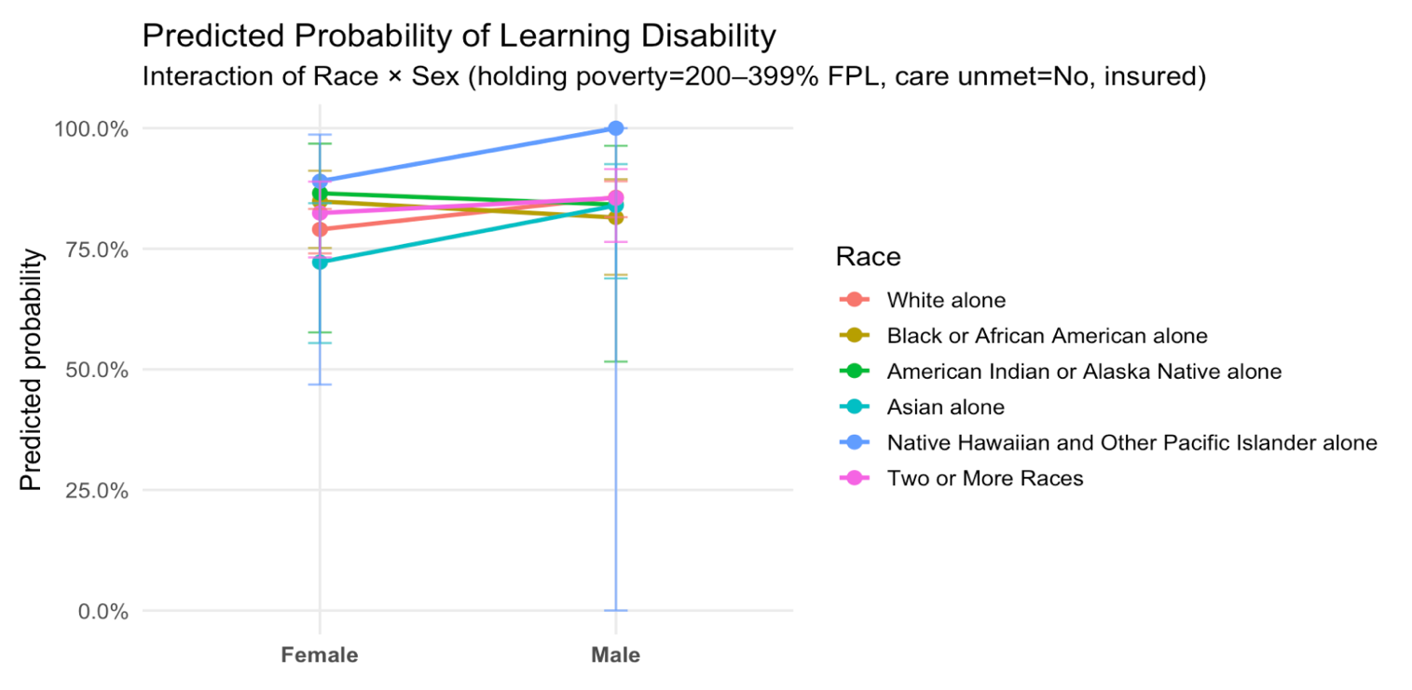
Figure 2 presents model-predicted probabilities of learning disability identification by race and sex, holding poverty group, insurance status, and healthcare access constant. Across nearly all racial groups, male children have higher predicted probabilities of identification than females, confirming the regression result that males are more likely to be diagnosed (OR ≈ 1.6). Asian children show the lowest predicted probabilities, suggesting potential under-identification, while Black and American Indian/Alaska Native children show higher rates relative to White peers, consistent with patterns of over-identification. The magnitude of the male–female gap varies by race, with the largest differences observed among Black and American Indian children. Wider confidence intervals for smaller groups, such as Native Hawaiian/Pacific Islander, indicate greater uncertainty and should be interpreted cautiously.
INTERPRETATION AND DISCUSSION
The results align closely with the original hypotheses that demographic and access-related factors shape the likelihood of learning disability identification. Consistent with expectations, the analysis finds that male children have significantly higher odds of being identified with a learning disability, confirming long-documented gender gaps in special education identification. This pattern holds across nearly all racial groups, though the magnitude of the male–female gap differs by race—supporting the hypothesis of an interaction effect.
The finding that Asian children have lower odds of identification than White children did surprise me however, it could be possible due to cultural stigma, limited language support, or parental reluctance to pursue formal diagnoses. Conversely, Black and American Indian/Alaska Native children show higher predicted probabilities of identification, consistent with evidence of over-identification and potential bias in referral or evaluation processes. These racial patterns reinforce the idea that systemic and institutional factors, not just student characteristics shape who receives learning disability labels.
Access-related predictors also behave as expected. Children who are insured, have no unmet healthcare needs, and those who come from higher-income households are substantially more likely to be identified. This highlights the critical role of healthcare access and socioeconomic resources in enabling early detection and referral. These differences are large enough to have meaningful consequences for equity in support and service delivery.
While the results support the hypotheses, several alternative explanations should be acknowledged. The observed gender and racial gaps could partly reflect differences in educational settings (e.g., school resources, teacher training, or state-level evaluation policies) not captured by the dataset. Additionally, parent-reported learning disability may introduce reporting bias—families with more education, English fluency, or healthcare access may be more aware of diagnoses, inflating disparities by access rather than true prevalence. The apparent “advantage” for higher-income and insured children may reflect better diagnostic visibility, not necessarily higher actual rates of learning disability.
FUTURE DIRECTIONS:
Taken together, these findings suggest that learning disability identification in the United States reflects both need and access. Over-identification among certain racial groups and under-identification among others indicate the need for standardized, culturally responsive screening protocols. Policymakers and education agencies could strengthen equity by:
- Integrating universal early screening for learning difficulties within public school systems, reducing dependence on parental advocacy or healthcare access.
- Expanding culturally and linguistically appropriate evaluation tools, especially for multilingual and Asian student populations.
- Training educators and evaluators to recognize implicit bias in referral and diagnosis processes.
- Improving interagency coordination between schools and healthcare providers so that children with limited insurance or unmet care can still access assessments.
These interventions could help shift the system from reactive identification to proactive and equitable support.

REFERENCES
Disability and Socio-Economic Status.” American Psychological Association, 2010. https://www.apa.org/pi/ses/resources/publications/disability
Okoli, Menkeoma Laura, Chukwuemeka E. Ogbu, Chioma O. Enyi, Ibuchim C. Okoli, Ronee E. Wilson, and Russell S. Kirby. “Sociodemographic and Socioeconomic Correlates of Learning Disability in Preterm Children in the United States - BMC Public Health.” BioMed Central, February 1, 2022. https://bmcpublichealth.biomedcentral.com/articles/10.1186/s12889-022-12592-4
Shifrer, Dara, Chandra Muller, and Rebecca Callahan. “Disproportionality and Learning Disabilities: Parsing Apart Race, Socioeconomic Status, and Language.” Journal of learning disabilities, 2011. https://pmc.ncbi.nlm.nih.gov/articles/PMC4133990/
Lauren Scannelli Jacobs and Jade Kissi. “Improving Access to Children’s Preventive Care: Medicaid Opportunities in School Settings - CHCS Blog.” Center for Health Care Strategies, August 26, 2025. https://www.chcs.org/improving-access-to-childrens-preventive-care-medicaid-opportunities-in-school-settings/

Disability and Socio-Economic Status.” American Psychological Association, 2010.
Okoli, Menkeoma Laura, Chukwuemeka E. Ogbu, Chioma O. Enyi, Ibuchim C. Okoli, Ronee E. Wilson, and Russell S. Kirby. “Sociodemographic and Socioeconomic Correlates of Learning Disability in Preterm Children in the United States - BMC Public Health.” BioMed Central, February 1, 2022.
Okoli, et al, Sociodemographic and Socioeconomic Correlates of Learning Disability in Preterm Children in the United States
Shifrer, Dara, Chandra Muller, and Rebecca Callahan. “Disproportionality and Learning Disabilities: Parsing Apart Race, Socioeconomic Status, and Language.” Journal of learning disabilities, 2011.
Disability and Socio-Economic Status.” American Psychological Association, 2010.
Lauren Scannelli Jacobs and Jade Kissi. “Improving Access to Children’s Preventive Care: Medicaid Opportunities in School Settings - CHCS Blog.” Center for Health Care Strategies, August 26, 2025
Laurent, et al. Improving Access to Children’s Preventive Care: Medicaid Opportunities in School Settings.

